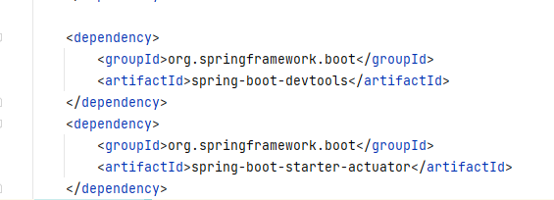

**Devtools:** Spring devtools are similar to nodemon, hot reload feature.

**Actuators:** This is a sub project of spring boot, it gives us some endpoints to manage and monitor the application.

By default, only /health endpoints are exposed. We can expose other endpoints via application.properties file.



